# Cybersecurity

# **Project 4.2.6 Phishing at Work**

**Use the following as a guide along with the instructions provided by PLTW for Project 4.2.6.**

#5 Create a plan of action to address the following questions:

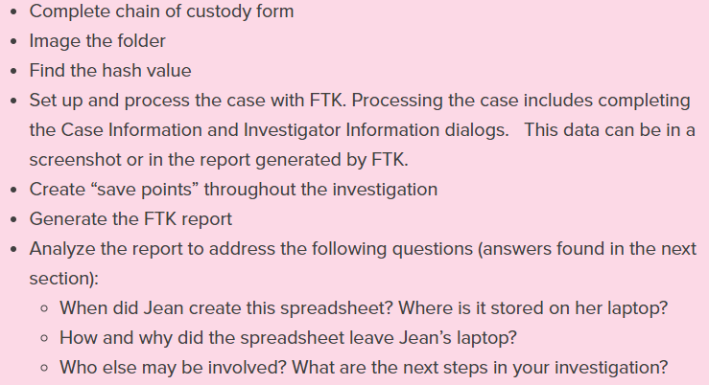 …this is done for you

#9 Document and analyze each step of your process with careful notes and screenshots of items that support your investigation.

1. When did Jean create this spreadsheet? Where is it stored on the laptop?

1. How and why did the spreadsheet leave Jean’s computer?

She replied to a email from George tucker who pretends to be alison

1. Who else may be involved? What would the next steps be in your investigation?Table

   Description automatically generated